**Dynamic cloud computing architecture for cloud-assisted internet of things in the era of Big-data, IoT and AI**

**Grid computing**

Grid computing is also called distributed computing. It is a processor architecture that combines multiple computing resources from multiple locations to achieve same goal. grid computing, the grid connects parallel nodes to form a group of computers. These groups of computers vary in size and can run on any operating system. Examples- mainly used in ATM, marketing research etc.

Grid computing includes the following three types of machines –

* control nodes- A group of servers that manage the entire network.
* Provider - A computer that contributes resources to the network resource pool.
* users: computers using network resources.

**Cloud service models-**

There are three types of cloud service models-

* [Infrastructure as a Service (IaaS)](https://www.javatpoint.com/cloud-service-models#IaaS)
* [Platform as a Service (PaaS)](https://www.javatpoint.com/cloud-service-models#PaaS)
* [Software as a Service (SaaS)](https://www.javatpoint.com/cloud-service-models#SaaS)

**Infrastructure as a service (IaaS)-** Infrastructure as a Service (IaaS) is a type of cloud computing service that provides required computing, storage, and network resources on-demand on a pay-as-per use basis.it is also known as **Hardware as a Service (HaaS).** The IaaS cloud platform layer eliminates the need for any organization to maintain its IT infrastructure. Examples of IaaS providers are-Amazon web services, Reliance communications etc.

IaaS supplier provides the subsequent services –

* Compute: Computing as a Service includes virtual central process units and virtual main memory for the Virtual machine that's provisioned to the end- users.
* Storage: IaaS supplier provides back-end storage for the storage of files.
* Network: Network as a Service (NaaS) provides networking parts like routers, switches, and bridges for the Virtual machine.
* Load balancers: It provides load levelling capability at the infrastructure layer.

**Platform as a service (PaaS)-** PaaS is a class of cloud computing that gives the platform and environment to permit the developers or programmers to create applications and services. PaaS services area unit hosted within the cloud and accessed by users merely via their browser. PaaS service provider have hardware and software package in its own infrastructure thus PaaS frees the user from having to put in in- house hardware and software to run and manage an application. The development and management of an application takes place independent of the hardware. Examples of the companies that provides for PaaS services are amazon web services, windows azure, IBM cloud.

**Software as a service (SaaS)-** software as a service is the most popular form of cloud computing. It is a model within which the service provider hosts application for the customers and make them accessible to those customers via the web.it is also known as on demand software. example of companies that provides SaaS services are Cloud Switch, Microsoft Office 365, Eloqua etc.

**Problem**

Cloud security issues are threats associated with cloud-hosted applications and other internet-only access arrangements. The problems range from unauthorized access to confidential data and identity theft. These issues are initiated by the illegal activities of cybercriminals for wide-ranging gains.

**Cloud service providers**

various cloud service provider companies are Microsoft azure, amazon web services (AWS), google cloud platform, IBM cloud services, Oracle cloud, digital ocean, Alibaba cloud etc.

1. **Microsoft azure**- Microsoft Azure is additionally referred to as Windows Azure. It supports varied in operation systems, databases, programming languages, frameworks that enable IT professionals to simply build, deploy, and manage through a worldwide network.

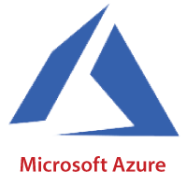

It additionally permits users to form completely different teams for connected utilities. Azure gives more than two hundred services, area unit divided into eighteen classes. These classes embody computing, networking, storage, IoT, migration, analytics, containers, mobile, computing, and, integration, management tools, alternative machine learning developer tools, security, databases, media identity, and net services

1. **Amazon web services (AWS)-** Amazon web service is a safe and **secure cloud service** provided by **Amazon**. It provides many services like data storage, computing power, content delivery, Relational Database, Email, Queue etc.

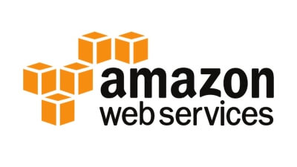

The main feature of AWS that it provides cost effective, provide various types of storage options and provides various **security services** like infrastructure security, data encryption like DDoS attack.